ContactManagement_Verify Contact notes _Instance44_12-Jul-2018_03-02-49_AM_SingleSignOn.png

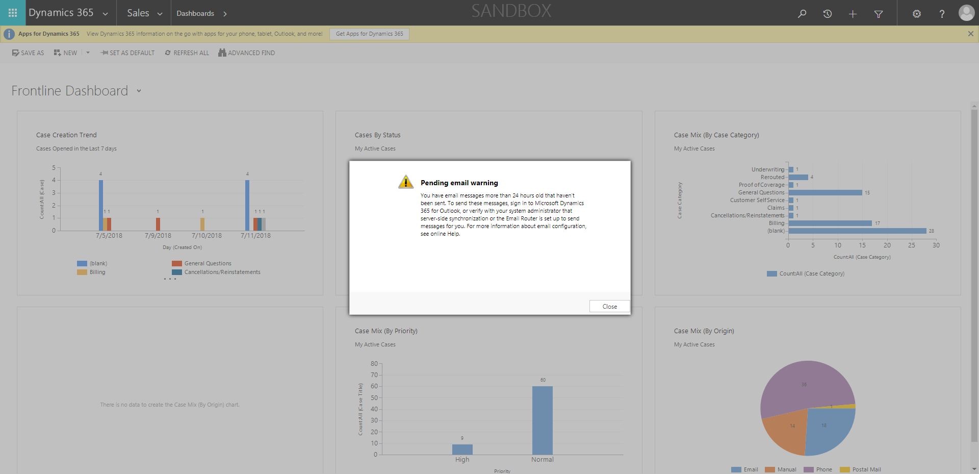

ContactManagement_Verify Contact notes _Instance44_12-Jul-2018_03-02-38_AM_MouseClickActiononStaleElement.png

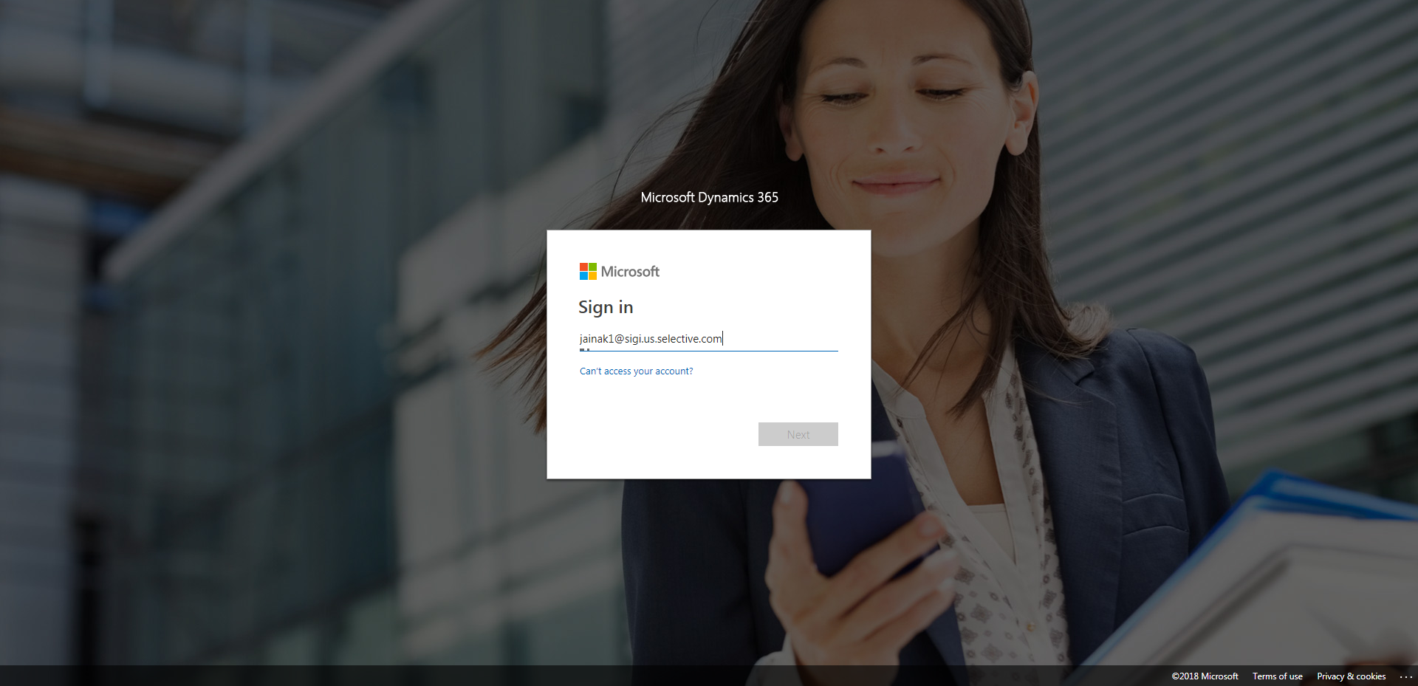

ContactManagement_Verify Contact notes _Instance44_12-Jul-2018_03-03-22_AM_VerifyingAllNotesofanindividual.png

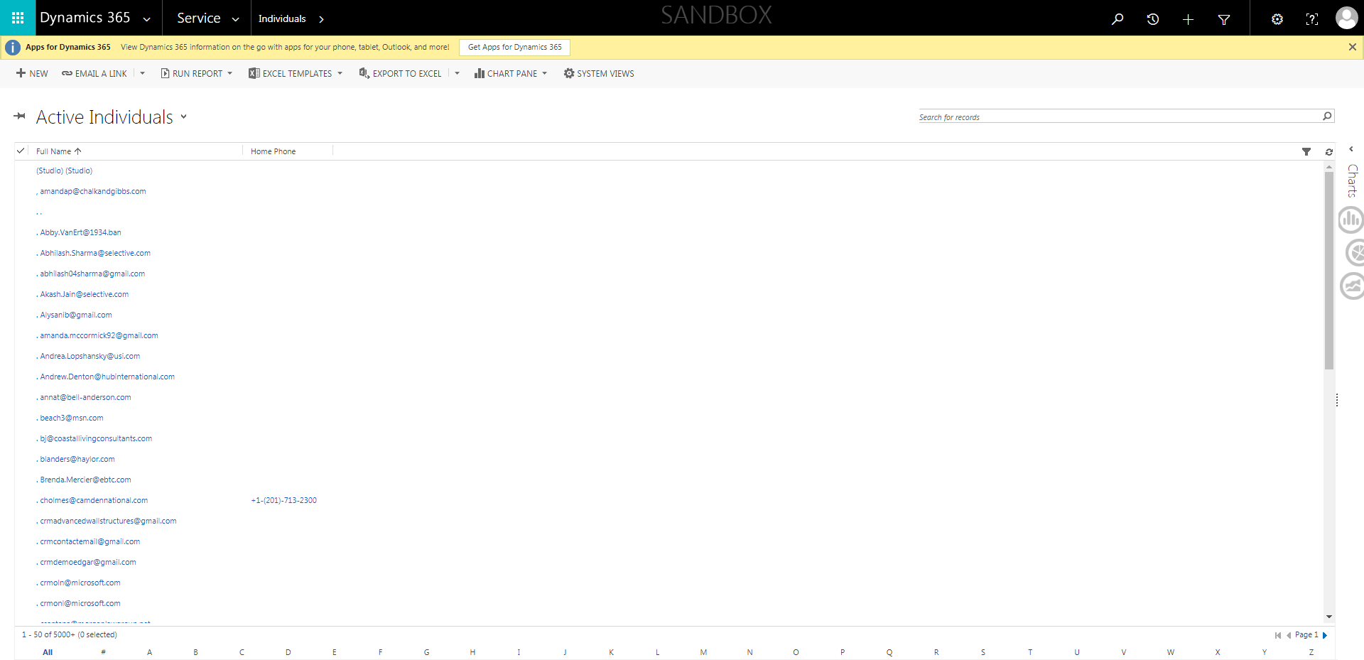

ContactManagement_Verify Contact notes _Instance44_12-Jul-2018_03-02-54_AM_SingleSignOn.png

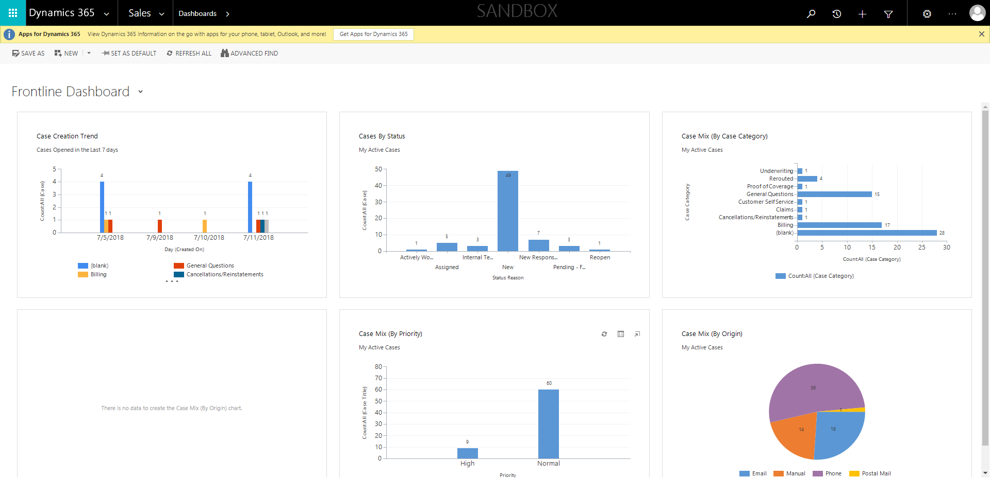

ContactManagement_Verify Contact notes _Instance44_12-Jul-2018_03-02-37_AM_EnterTextAction.png

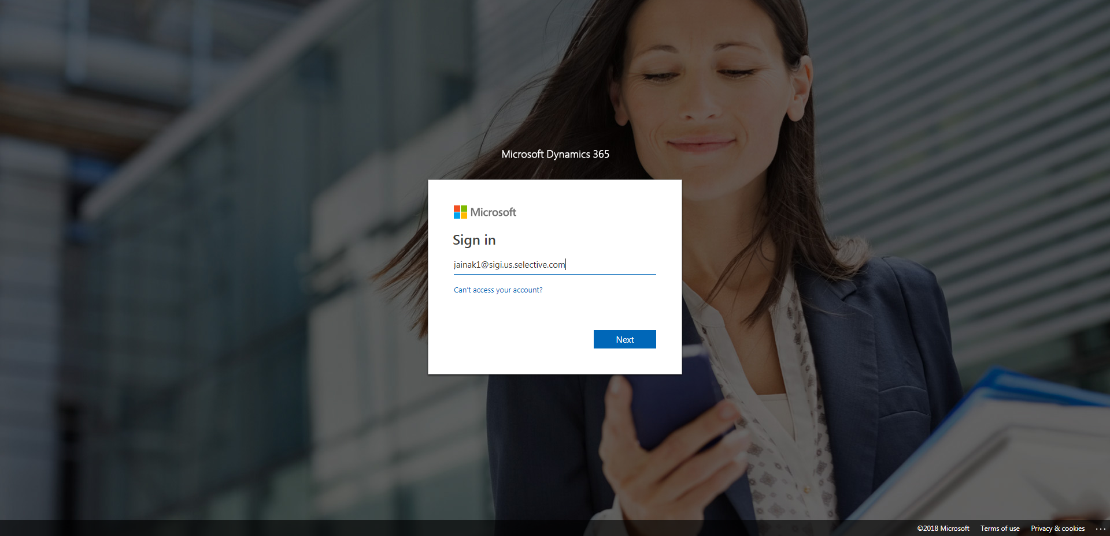

ContactManagement_Verify Contact notes _Instance44_12-Jul-2018_03-02-35_AM_MouseClickActiononStaleElement.png



ContactManagement_Verify Contact notes _Instance44_12-Jul-2018_03-03-12_AM_Validatingcontactentitynavigation.png

